Highlights and Decisions
The Canadian Council of Churches Governing Board Meeting
November 16-18, 2016 – Crieff Hills Retreat Centre, Puslinch, ON
The Canadian Council of Churches (the Council) is the broadest and most inclusive ecumenical body in Canada. The Governing Board brings together representatives from Anglican, Evangelical, Free Church, Eastern Orthodox and Oriental Orthodox, Historic Reformed, and Catholic member denominations.
The purposes and functions of the Council shall be to serve God's mission in the world, to give expression to the unity which is offered to the world through Jesus Christ, to witness to the continuing renewal of the Church by the Holy Spirit, to promote the growth of ecumenical and missionary obedience among all Christians, and to facilitate common action by the member churches.
At this semi-annual meeting of the Governing Board we:
- Shared important news and prayer concerns of Christian denominations in Canada.
- Resumed the usual planning process to nominate new Executive Committee leadership for the Council for the
2018-2021 Triennium.
- Examined the surprising developments in synthetic biology (“genetic engineering on steroids”) and agreed to organize an international event on synthetic biology in collaboration with the World Council of Churches.
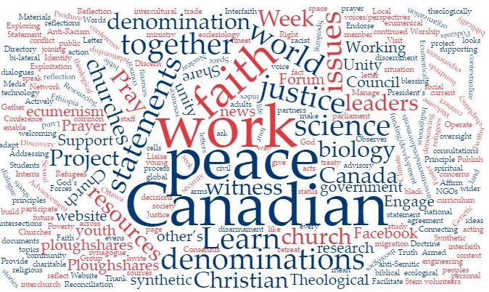
- Presented testimonies on peace as the heart of ecumenism, in particular Catholic, Quaker, Orthodox, and United Church traditions on peace.
- Reviewed indicators of reach as the Commission on Faith and Witness moves from print resources to digital episodes on social media and on-line.
- Prayed using the 2017 Week of Prayer for Christian Unity materials from Germany (country marking the 500 year Reformation).
- Finalized a Statement on Religious Freedom and previewed an on-line interfaith directory.
- Advanced the growing collaboration and integration of the Canadian Churches Forum for Global Ministries (the Forum) and the Council in intercultural ministry.
- Adopted the 2017 budget of The Canadian Council of Churches and its operating division Project Ploughshares, and authorized its Executive Committee to approve the 2017 budget of the Forum.
- Were moved by the astounding research and action for peace and disarmament in Canada and worldwide of the Project Ploughshares team and expressed strong support for their work.
- Learned from The Rev. Darren Roorda, of the Christian Reformed Church in North America and Archbishop Don Bolen of the Canadian Conference of Catholic Bishops how they take decisions as denominations.
- Worshipped, prayed, shared testimonies, and sang together in the Salvation Army and Christian Church (Disciples of Christ), Ethiopian Orthodox Tewahedo, and Salvation Army traditions.
- Debated the relationship of “Faith and Witness” and “Justice and Peace” work, and how both relate to theology.
- Received an update from President Alyson Barnett-Cowan on her presidential priorities: responses to the Truth and Reconciliation Commission Calls to Action, and visits to member denominational offices.
- Publicly decried together the recent attacks of racist vandalism on places of worship in Ottawa, our nation’s capital.
The next meeting of the Governing Board is scheduled for May 24-26, 2017 at the University of Saint Paul in Ottawa. Visit www.facebook.com/CCC.CCE for more pictures and highlights!

